Fresno Fair Home Arts Exhibits
To register online: https://fresnh.fairwire.com/
To access the complete Competitive Exhibits booklet online: https://cdn.saffire.com/files.ashx?t=fg&rid=FresnoFair&f=2022_Home_Arts.pdf
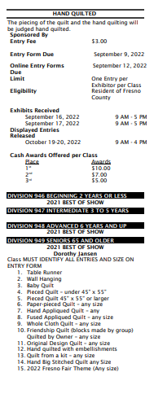
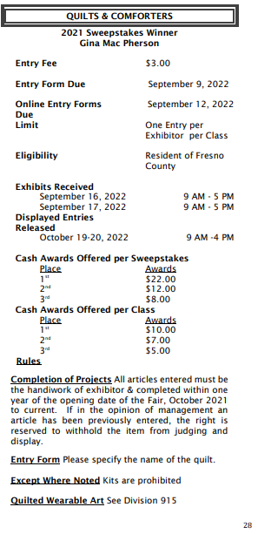
The Home Arts Section for 2022

